Assignment 5

1. Create and insert data in – “emp” and “dept”(Check HR schema, table

names may be different.)

Ans 1)

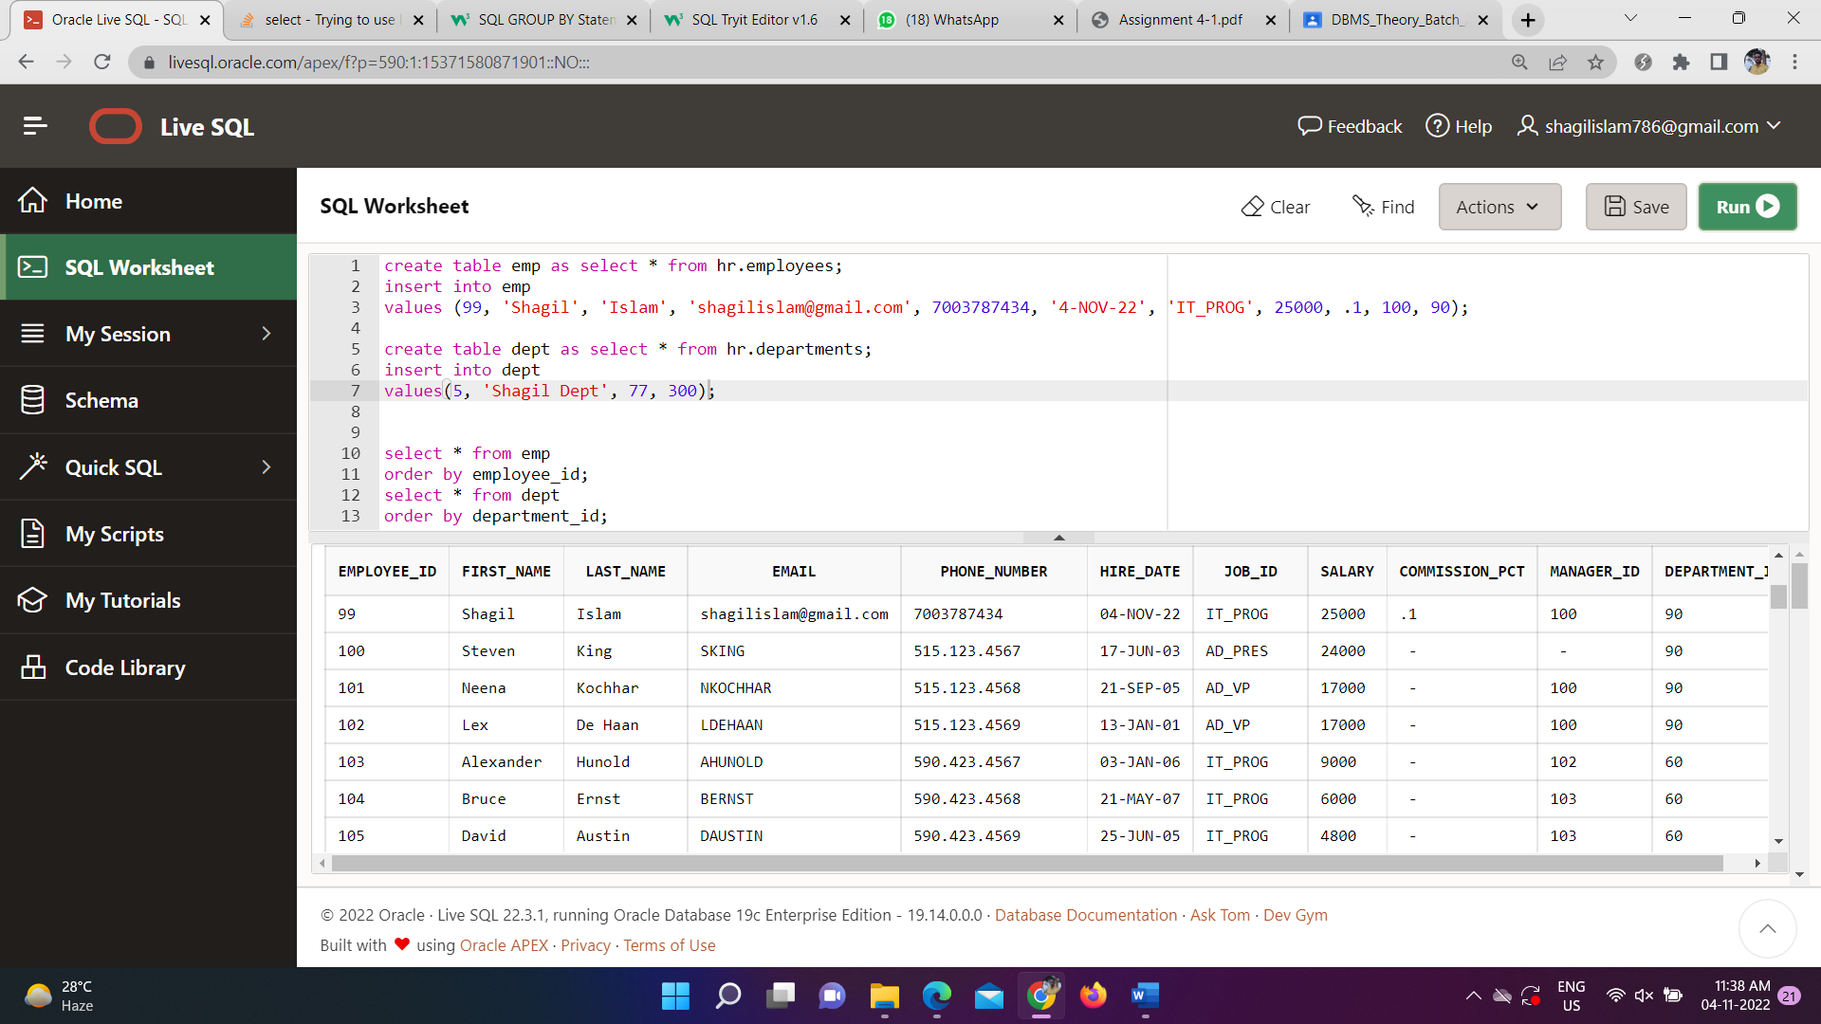

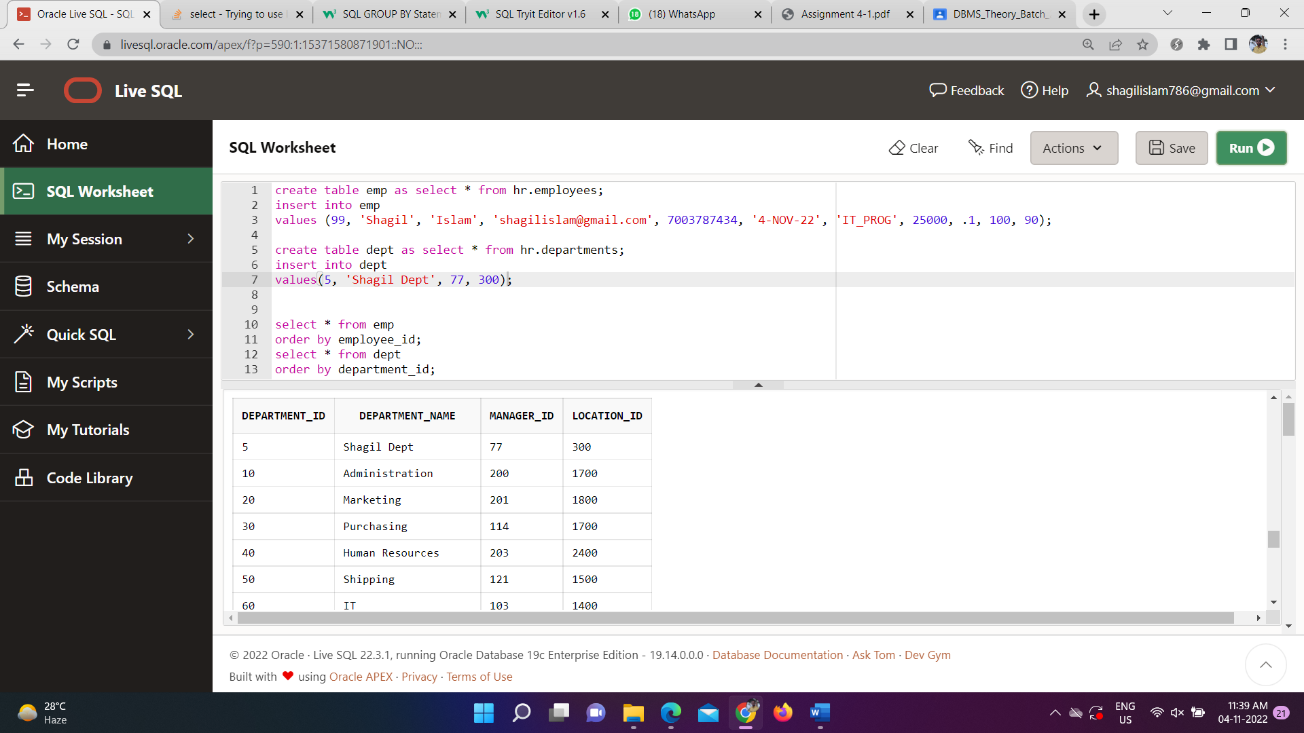

2. Display name of employees , department name and job name for each

Employee

Ans 2)

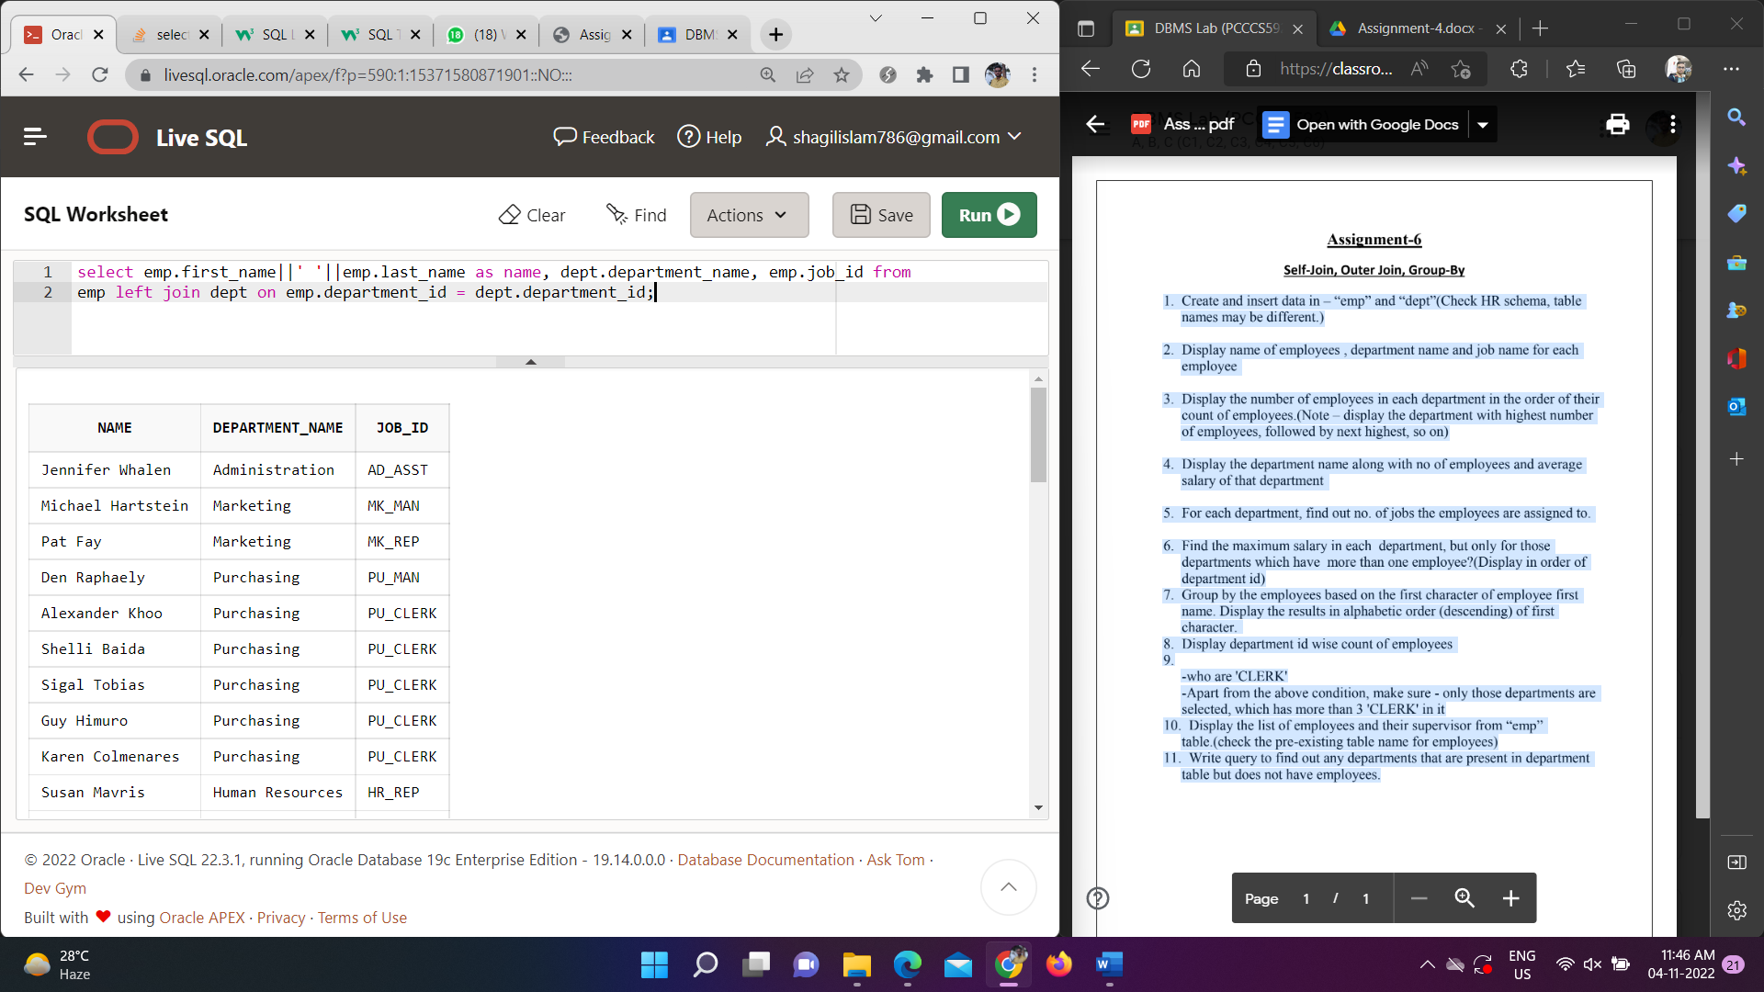

3. Display the number of employees in each department in the order of their

count of employees.(Note – display the department with highest number

of employees, followed by next highest, so on)

Ans 3)

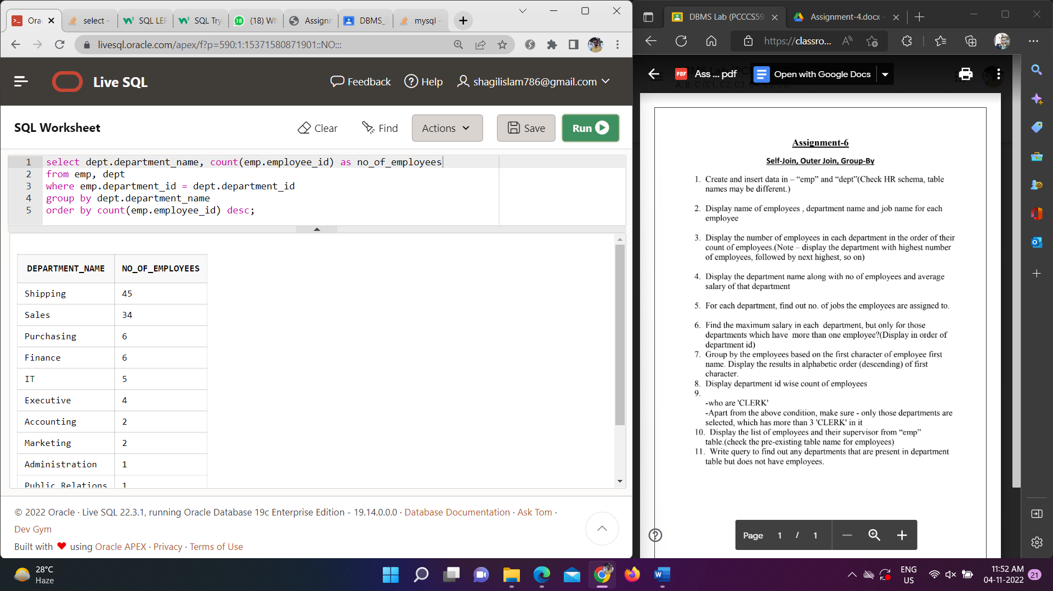

4. Display the department name along with no of employees and average

salary of that department

Ans 4)

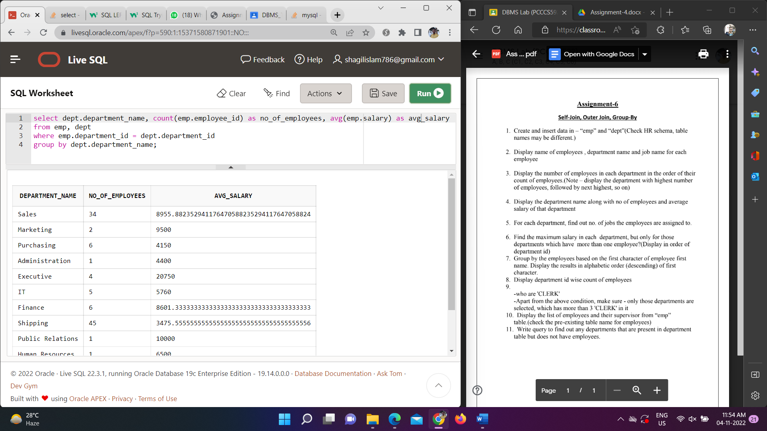

5. For each department, find out no. of jobs the employees are assigned to.

Ans 5)

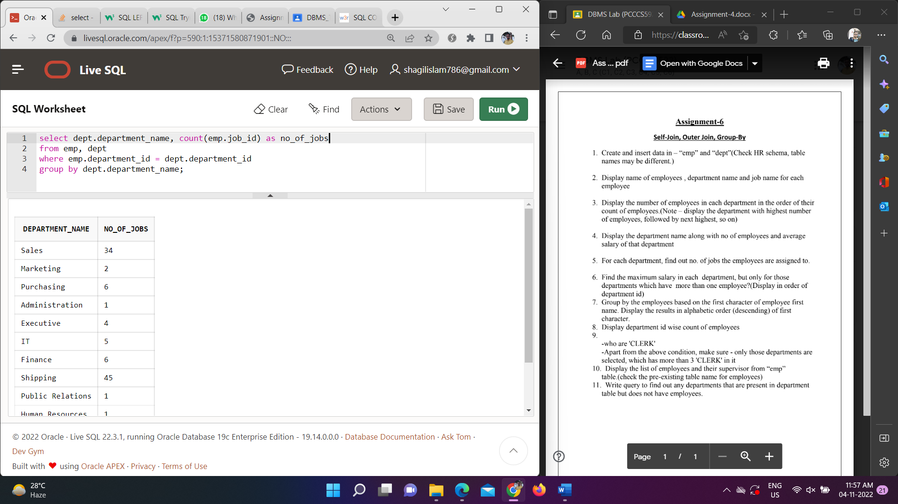

6. Find the maximum salary in each department, but only for those

departments which have more than one employee?(Display in order of

department id)

Ans 6)

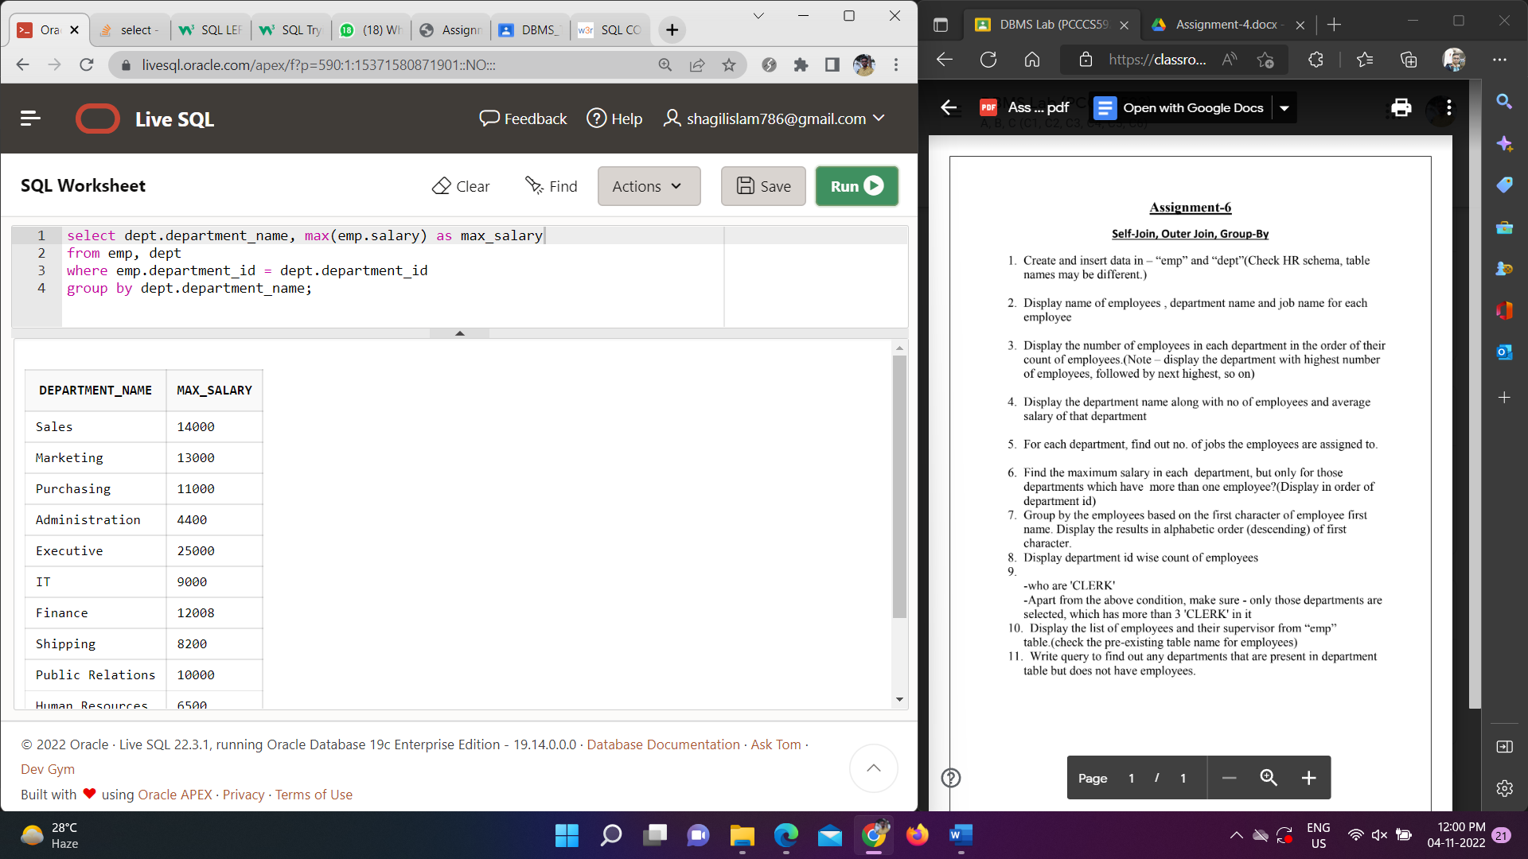

7. Group by the employees based on the first character of employee first

name. Display the results in alphabetic order (descending) of first

character.

Ans 7)

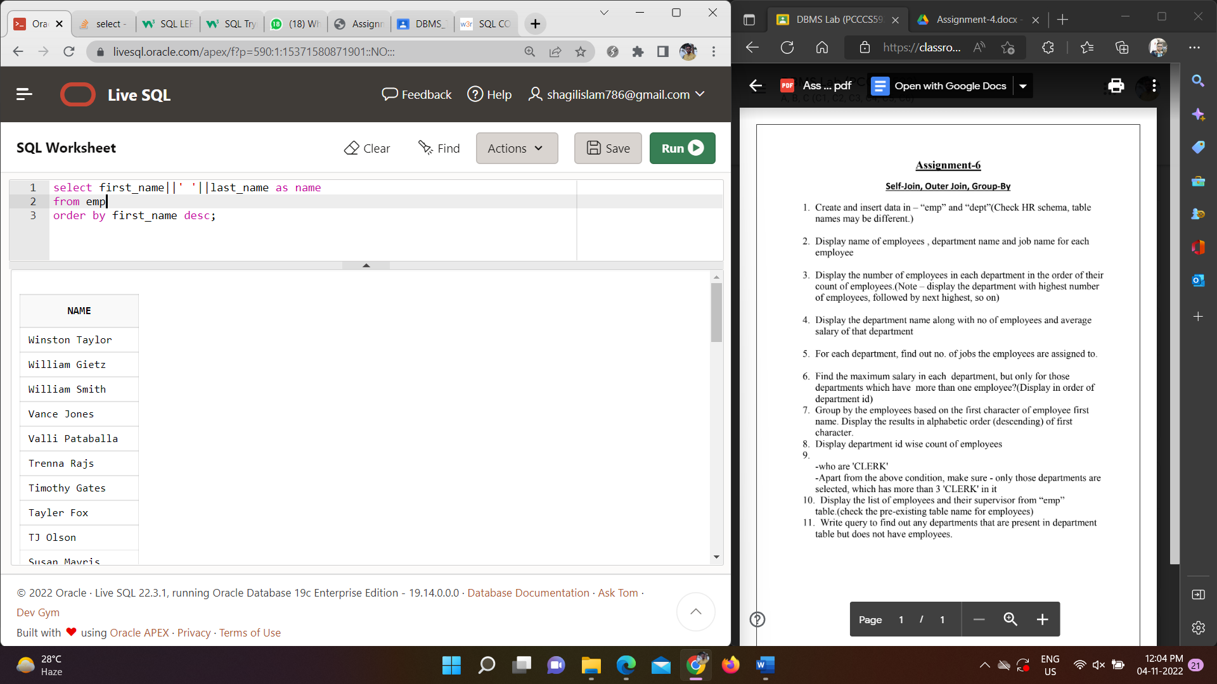

8. Display department id wise count of employees

Ans 8)

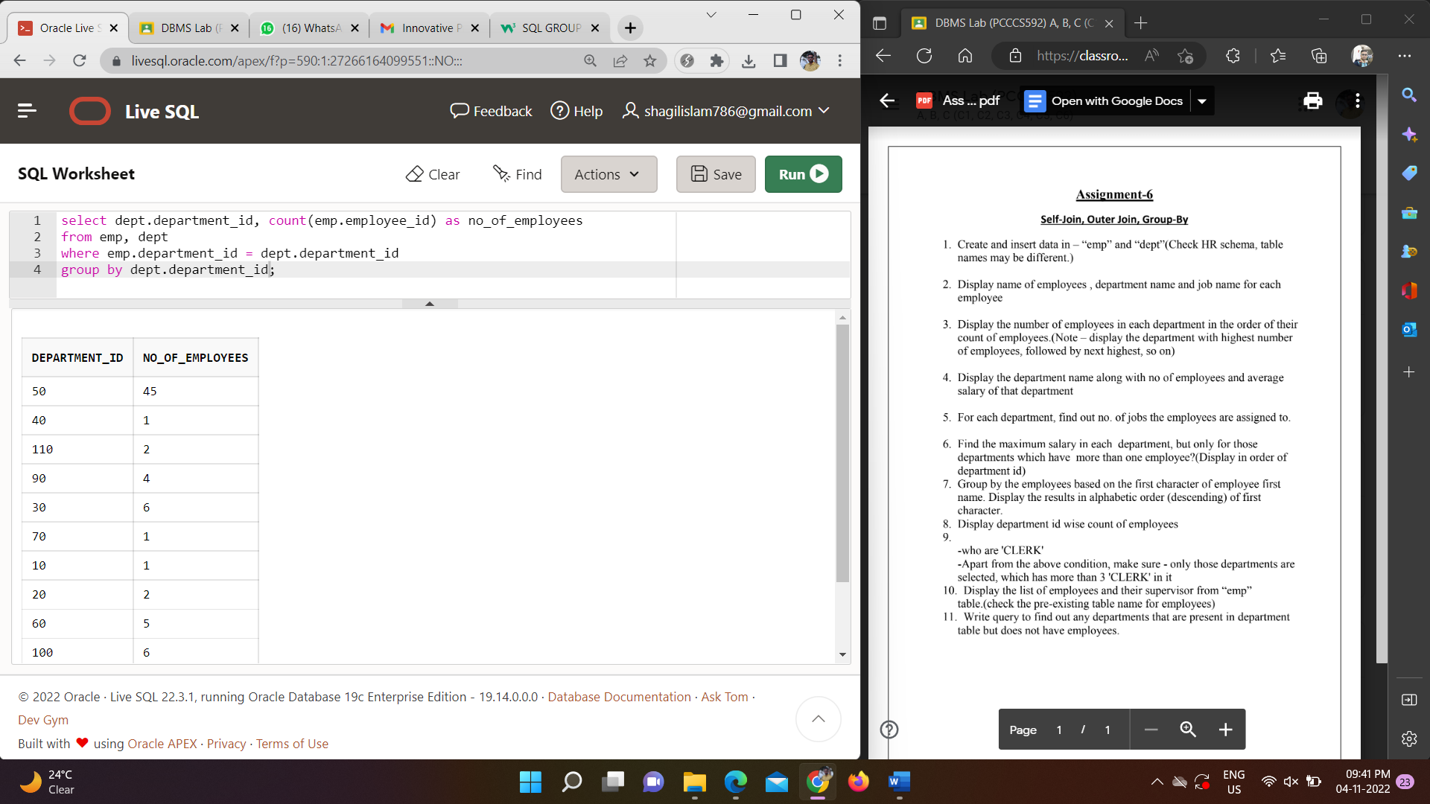

9.

-who are 'CLERK'

-Apart from the above condition, make sure - only those departments are

selected, which has more than 3 'CLERK' in it

Ans 9)

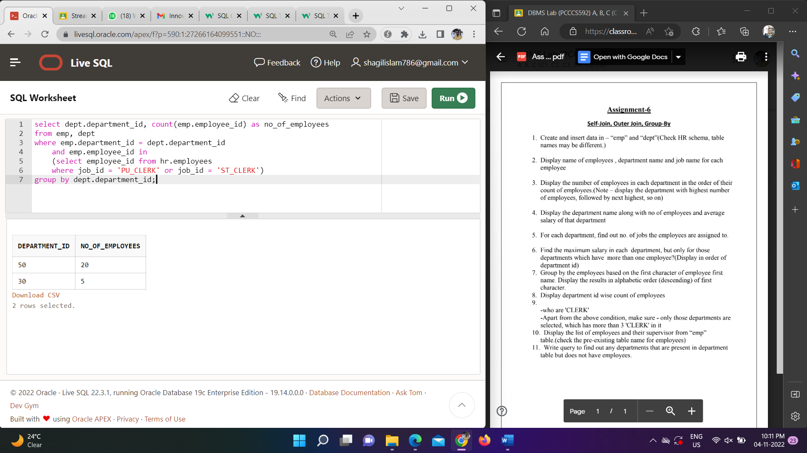

10. Display the list of employees and their supervisor from “emp”

table.(check the pre-existing table name for employees)

Ans 10)

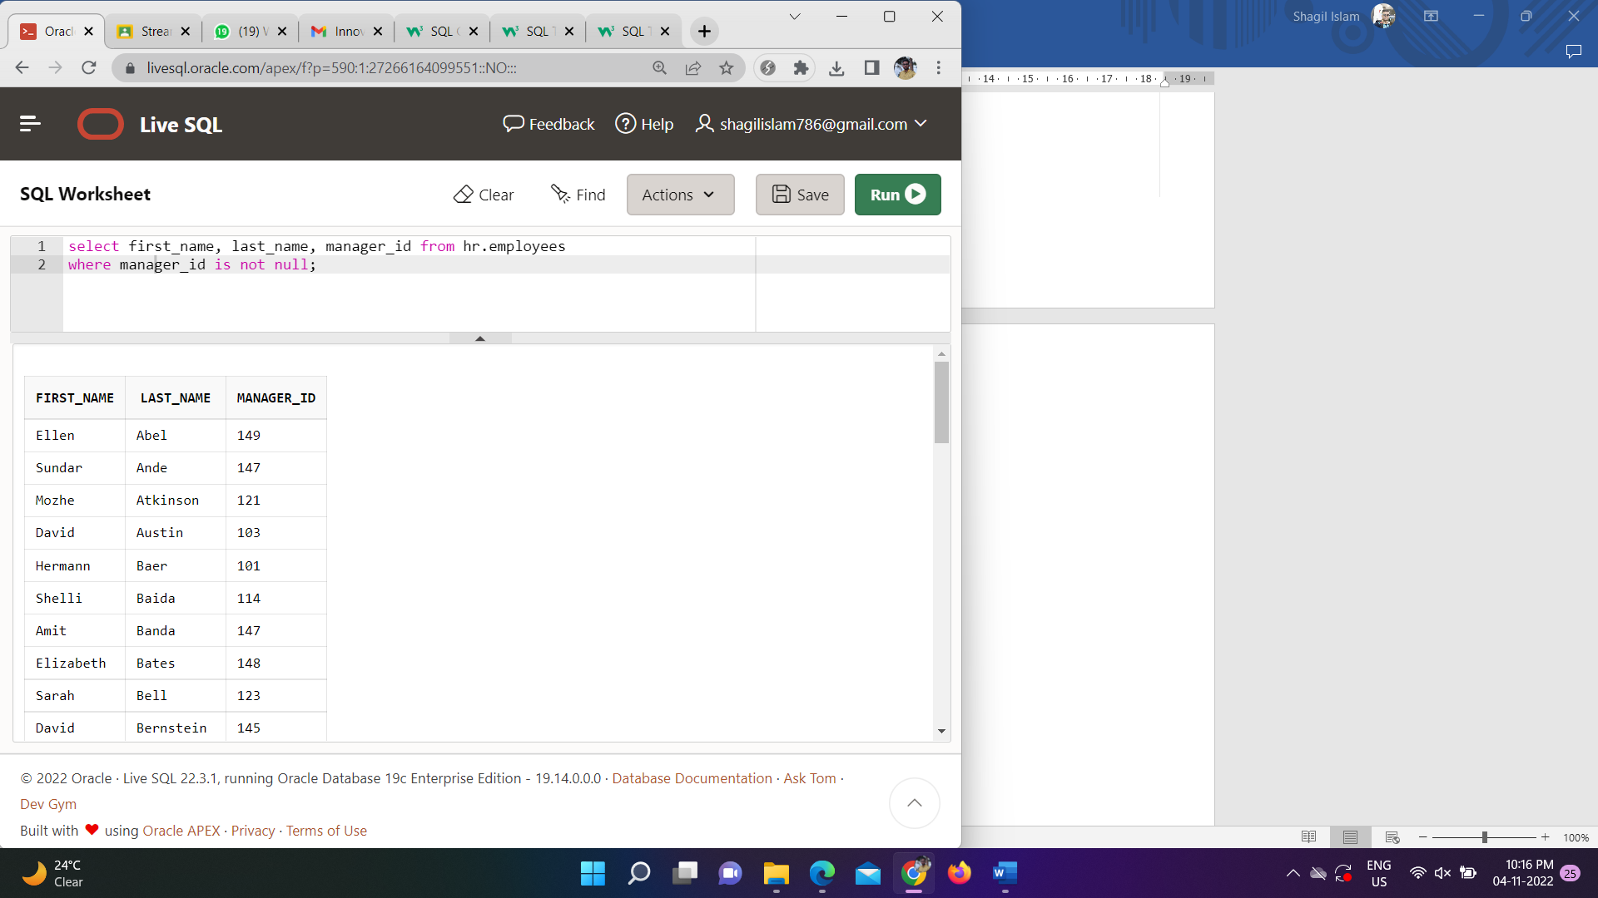

11. Write query to find out any departments that are present in department

table but does not have employees.

Ans 11)

